**Audacia Ball**

Short documentation

**Introduction**

This documentation has been made following a development challenge Audacia proposed a potential employee. The goal was to develop an application enabling users to track their table football games. The detailed requirements of this challenge can be found on the Git repository (see chapter “resources”).

**Project infrastructure**

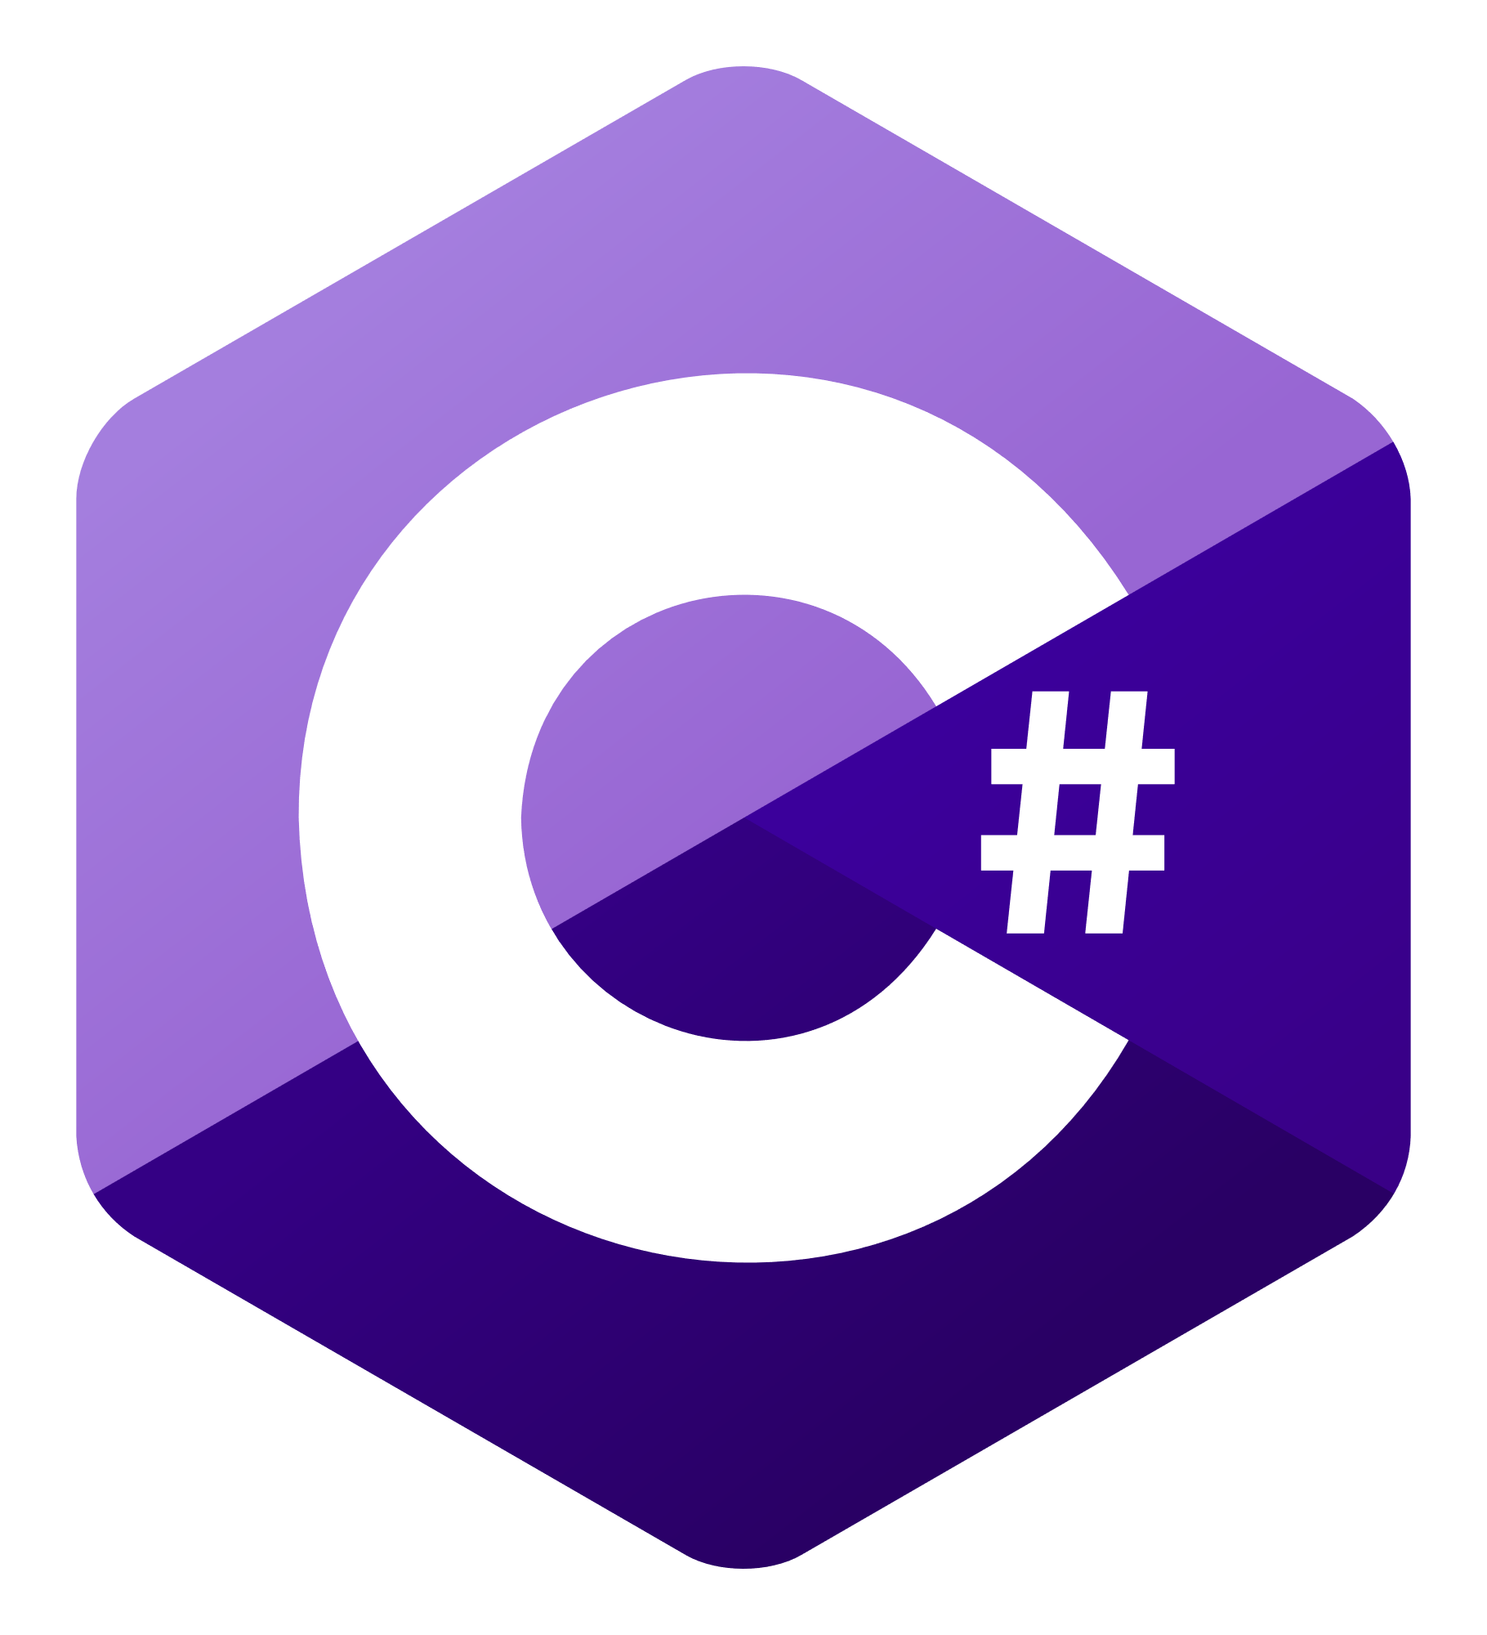

SQL DB

REST API

**Explanation**

This project uses many different technologies.

* SQL Database hosted on Azure, to store the data used by our app.
* REST API written in C# with Visual Studio and hosted on Azure, to send and receive data from our SQL Database.
* Vue.js UI hosted on Heroku, to interact with our components and use the app.
* GitHub to push and deploy our code. GitHub is directly linked to Heroku, which enables us to deploy easily Node.js and Vue.js code online.

**Resources**

|  |  |
| --- | --- |
| What | URL |
| Application | <https://audaciaballui.herokuapp.com/> |
| GitHub repository | <https://github.com/nicolassolioz/AudaciaBall> |
| API | <https://audaciaballapi20200911031401.azurewebsites.net> |

**Challenge requirements**

|  |  |  |
| --- | --- | --- |
| **Challenge** | **Challenge met?** | **Remarks** |
| US#1: As a user, I want to start a new game between two teams so that I can keep track of score  as the game is being played. | Yes |  |
| US#2: As a user, I want to create a game that has already been played so that I can enter the  result of that game. | Yes | When creating a new game, the user can set a starting score for both blue and red teams, this allows him to input an existing game into the app. |
| US#3: As a user, I want to be able to create teams with one or two players so that I can reuse the  teams when I create new games. | Yes |  |
| US#4: As a user, I want to see a dashboard with team and individual player statistics so that I can  see who is the ultimate champion. | Yes |  |
| The dashboard shows all teams/players sorted by Win Ratio, GD | Yes |  |
| Show the history/log of games played by one player | Yes |  |
| Shows the history/log of games played by one team vs another (optional) | Yes | In the player and team management view, we can click on “?” to see the games played by the selected player. |
| Shows the confrontation statistics, e.g.  Team N wins in direct confrontations: 10 - 2  Shows the history/log of games played by one team vs another | Yes | In the page “See all games played” we can see the result of every single match. |

**Further notes**

Audacia Ball was deployed on 3 separate machines, one machine for the API, one machine for the database and one machine for the user interface. These machines are not optimized and aren’t very powerful, so the time response from the application is a little slow. In a real-life scenario, an app in production would use better, more powerful resources.

All code is commented and should be self-explanatory. For any questions, I’m available at [nicolas.solioz@bluewin.ch](mailto:nicolas.solioz@bluewin.ch) or 079 489 78 09.

**Date – Version**

September 12th 2020, Version 1